Zona Global Village Indigenous Peoples Network
Honoring Ancestral Knowledge and Promoting Sovereignty in Indigenous Health

AIDS 2026
Rio de Janeiro, Brazil July 27–30, 2026
Hosted by CAAN Communities, Alliances and Networks
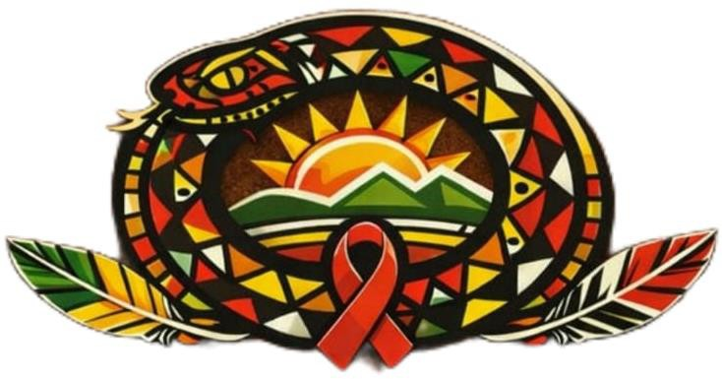

AGENDA

Monday, July 27, 2026: 10:30 a.m. to 5:00 p.m.
Time | Session and description | Moderator
10:30 – 11:30 | Mayan Indigenous Ceremony | Juana Lopez (Guatemala)
11:30 – 12:30
12:30 – 13:00 | Opening Meeting: Welcome by the Indigenous Host Nation (Brazil), Opening Prayer/Ceremony, CAAN Welcome,  Guardian of Knowledge, Agenda Brief
13:00 – 13:30 | Opening lecture (suggested)
13:30 – 15:00 | PANEL: The Impact of Indigenous Women Living with HIV on | Maritza Segura
13:30 – 15:00 | the Region on Access to Comprehensive Care and Next-Generation Medicines | (Moderator/Ecuador)  Mary Chuc Chu (Guatemala)
 |  | Ruth Mamani (Bolivia)
 |  | Juana Lopez (Guatemala)
15:00 – 15:45 | FEAST: This session presents the Feast Center for Indigenous Research on STBBI as a transformative event | Freddy Monasterio (First Nations, Inuit,
 | Indigenous-led model, based on the transfer of authority to | and Métis communities
 | communities instead of systems of research, care and knowledge. | along Tortuga
 |  | Island)
15:45 – 16:00 | Coffee break

16:00 – 17:00 | Rio Negro is an authorial musical show that presents the universe of Ixé Pop Amazônico, an artistic language created by Eric Max that unites contemporary music, indigenous sounds, performance, ancestry and audiovisual.  The presentation celebrates the culture of the native peoples of the Amazon and proposes reflections on identity, territory, diversity, resistance and healing through art. | Eric Max Sales Guimarães (Bajo Río Negro, Amazonas)

Tuesday, July 28, 2026: 10:30 a.m. to 6 p.m.
Time | Session and description | Moderator
10:30 – 10:45
10:45 – 11:45 | Many Feathers, One Flight  Every feather tells a story.  Join us for an interactive experience where you'll create a symbolic paper feather that reflects your journey, your culture, your hopes, your resilience, or the teachings you carry. Through storytelling, creativity, and conversation, we'll celebrate the unique experiences each person brings while exploring how our individual stories weave together into a stronger, more connected community.  No artistic experience is needed - just bring your story. | Tawnya Crowshoe  (Canada)
11:45 – 12:00 | Coffee break
12:00 – 13:00 | Cinema and debate: Territory of the virus  A theatrical film and facilitated discussion led by people living with HIV that explores stigma, discrimination, prevention, treatment, and the realities experienced by Indigenous peoples through art and dialogue. | Laurinha de Souza Brelaz (Brazil)
12:30 – 13:15
13:15 – 14:45 | PANEL: Access to Next-Generation Medicines: On Trade Barriers, Access to Health, Patents, and Challenges in the Region in Relation to Medicines. | Willy Morales (Moderator/Chile) Fernanda Moreira (ITPC - Brazil) Daniel Ambelis de León (ITPC - Guatemala)  Luz Marina Umbasia  Bernal (ITPC - Colombia)
14:45 – 15:00 | Coffee break
15:00 – 16:30 | Female Voices:  The Impact of Indigenous Women Living with HIV in the Region on Access to Comprehensive Care and Next-Generation Medicines | Moderator: Maritza Segura (Ecuador) Mary Chuc Chu (Guatemala)  Ruth Mamani (Bolivia) Juana López (Guatemala)
16:30 – 16:45 | Break
16:45 – 17:15 | Introduction of PATSIN: Trauma-Informed Practice in HIV  Care for Aboriginal Peoples  (Positive Network of Aboriginal and Torres Strait Islander Islanders) and  its 21-year journey - from IPN+, (Indigenous Positive  Network) to the organization it is today.  PATSIN represents the voices of lived experience and the  important role we play in defending and supporting our crowd  living with HIV or at risk of developing HIV. | Michelle Tobin  (Australia)
17:15 – 18:00 | Daily Reflection Circle

Wednesday, July 29, 2026: 10:30 a.m. to 6:00 p.m.
Time | Session and description | Moderator
10:30 – 11:00

11:00 – 12:00
12:00 – 13:00 | Life, Voice and Territory: HIV in girls, women and diverse indigenous communities  This session will share lessons learned through Indigenous-led research and explore how community knowledge, self-determination, and culturally relevant approaches can strengthen dignity, resilience, and well-being. We will also emphasize the importance of giving visibility to Indigenous sexual and gender diversity, whose voices are often absent in research, public policy, and health services. | Belgium Ledesma  (Peru)
13:00 – 13:30 | Daily Reflection
13:30 – 14:30 | Cost-effectiveness of cross-cultural and state-of-the-art strategies in the HIV response: (Pillars 95-95-95) | Maritza Segura (Ecuador)
14:30 – 14:45 | Coffee break
14:45 – 16:15 | Climate change and illegal and predatory exploitation as  factors driving mental health challenges and barriers to HIV care | Aluísio Campos (Brazil)
15:00 – 16:00
16:30 – 18:00 | Walk like a man, talk like a man:  The focus of this workshop will be on masculinity and the various and varied ways people can interpret being a man in today's world. Presented by Dr Tāwhanga Nopera, Māori artist and scholar, this session aims to offer participants different ways of considering their identity and practices in relation to the work of ending HIV transmission and supporting people living with HIV. Specifically, this session aims to help participants hone their relational skills in very embedded ways. | Nopera Gallery  (Aotearoa)

Thursday, July 30, 2026: 10:30 a.m. to 6:00 p.m.
Time | Session and description | Moderator
10:30 – 10:45
10:45 – 11:45 | Many Feathers, One Flight  Every feather tells a story.  Join us for an interactive experience where you'll create a symbolic paper feather that reflects your journey, your culture, your hopes, your resilience, or the teachings you carry. Through storytelling, creativity, and conversation, we'll celebrate the unique experiences each person brings while exploring how our individual stories weave together into a stronger, more connected community.  No artistic experience is needed - just bring your story. | Tawnya Crowshoe  (Canada)
11:40 – 12:00 | Coffee Break
12:00 – 12:30 | Daily openness and reflection
12:30 – 14:00 | PANEL: Indigenous Peoples Responding to AIDS: 40 Years of Exclusion | Willy Morales (Moderator/Chile) Jose Yac (Guatemala) Ruth Mamani (Bolivia) Jeiser Suárez (Peru) Beth Sua DeGyvez Gallego (México)  Maximiliano Borquez (Chile)
14:00 – 14:30
14:30 – 14:45
14:45 – 15:30 | Active participation of indigenous peoples to strengthen the national health response in Guatemala:  Exploring indigenous leadership, ancestral knowledge, traditional midwives, intercultural health systems, and  Community engagement to strengthen equitable and culturally relevant health care. | Dr. Mario Alfonzo Tipol Yoj (Guatemala)
15:30 – 15:45 | Pause
15:45 – 16:15 | Building Bridges: Women, Art, and Intersectionality in the Fight Against AIDS: The film serves as an artistic and cultural tool focused on intersectionality and the fight against HIV/AIDS. Specifically, its full title—Building Bridges: Women, Art, and Intersectionality in the Fight Against HIV/AIDS—highlights its core mission to explore how women navigate life, health, and social stigma through creative expression.  Art as activism: The documentary revolves around "artivism" (artistic activism). It documents how creative media empowers women, amplifies their voices, and serves as an educational shield against gender discrimination and  Health-related bias. | Letícia Borges de Assis Laurinha Brelaz (Brazil)

 | Building connections: The "bridges" mentioned in the title mean breaking down the isolation around people living with HIV by creating connections between artistic communities, feminist networks, and public health narratives.
16:15 – 17:00 | Daily Reflection Circle
17:00 – 18:00 | Regional Closing Ceremony | (Led by local indigenous hosts, with  support from CAAN)

